**PHYSICS**

**YEAR 12**

**Unit 3**

**2015**



SOLUTIONS

***TIME ALLOWED FOR THIS PAPER***

Reading time before commencing work: Ten minutes

Working time for the paper: Three hours

***MATERIALS REQUIRED/RECOMMENDED FOR THIS PAPER***

**To be provided by the supervisor:**

* This Question/Answer Booklet; ATAR Physics Formulae and Data Booklet

**To be provided by the candidate:**

* Standard items: pens, pencils, eraser or correction fluid, ruler, highlighter.
* Special items: Calculators satisfying the conditions set by the SCSA for this subject.

***IMPORTANT NOTE TO CANDIDATES***

No other items may be taken into the examination room. It is **your** responsibility to ensure that you do not have any unauthorised notes or other items of a non-personal nature in the examination room. If you have any unauthorised material with you, hand it to the supervisor **before** reading any further.

**Structure of this paper**

|  |  |  |  |  |  |
| --- | --- | --- | --- | --- | --- |
| Section | Number of questions available | Number of questions to be answered | Suggested working time  (minutes) | Marks available | Percentage of exam |
| Section One:  Short answer | 12 | 12 | 50 | 54 | 30 |
| Section Two:  Extended answer | 6 | 6 | 90 | 90 | 50 |
| Section Three:  Comprehension  and data analysis | 2 | 2 | 40 | 36 | 20 |
|  |  |  | **Total** | 180 | 100 |

**Instructions to candidates**

1. The rules for the conduct of Western Australian external examinations are detailed in the *Year 12 Information Handbook 2017.* Sitting this examination implies that you agree to abide by these rules.
2. Write answers in this Question/Answer Booklet.
3. When calculating numerical answers, show your working or reasoning clearly. Give final answers to **three** significant figures and include appropriate units where applicable.

When estimating numerical answers, show your working or reasoning clearly. Give final answers to a maximum of **two** significant figures and include appropriate units where applicable.

1. You must be careful to confine your responses to the specific questions asked and follow any instructions that are specific to a particular question.
2. Spare pages are included at the end of this booklet. They can be used for planning your responses and/or as additional space if required to continue an answer.
   * Planning: If you use the spare pages for planning, indicate this clearly.
   * Continuing an answer: If you need to use the space to continue an answer, indicate in the original answer space where the answer is continued, i.e. give the page number. Refer to the question(s) where you are continuing your work.

**Section One: Short response 30% (54 marks)**

This section has **twelve** **(12)** questions. Answer **all** questions. Write your answers in the space provided.

When calculating numerical answers, show your working or reasoning clearly.

Give final answers to three significant figures and include appropriate units where applicable.

When estimating numerical answers, show your working or reasoning clearly. Give final answers to a maximum of two significant figures and include appropriate units where applicable.

Spare pages are included at the end of this booklet. They can be used for planning your responses and/or as additional space if required to continue an answer.

● Planning: If you use the spare pages for planning, indicate this clearly at the top of the page.

● Continuing an answer: If you need to use the space to continue an answer, indicate in the original answer space where the answer is continued, i.e. give the page number. Fill in the number of the question that you are continuing to answer at the top of the page

Suggested working time for this section is 50 minutes.

**Question 1**

The table below shows some data for two planets orbiting a distant star in another galaxy.

|  |  |  |  |  |  |
| --- | --- | --- | --- | --- | --- |
| Planets | Mass (kg) | Orbital radius (m) | Radius of planet (m) | Length of one day (s) | Orbital period (s) |
| Alpha | 1.15 x 1025 | 4.50 x 1011 | 7.9 x 106 | 9.6 x 104 | 8.50 x 107 |
| Beta | 1.60 x 1024 | 9.00 x 1011 | 3.8 x 106 | 4.8 x 104 | - |

Calculate the value for the orbital period of Beta using the appropriate data in the table.

(5 marks)

|  |  |
| --- | --- |
| Required Data: $$r_{ALPHA}=4.50 × {10}^{11}m; r_{BETA}=9.00 × {10}^{11}m$$ $$T_{ALPHA}=8.50 × {10}^{7}s; T_{BETA}= ?$$ | 1 mark |
| According to $r^{3}= \frac{GmT^{2}}{4π^{2}}, {r^{3}}/{T^{2}}=constant$ | 1 mark |
| $$∴ {{\left(r_{ALPHA}\right)}^{3}}/{{\left(T_{ALPHA}\right)}^{2}}= {{\left(r_{BETA}\right)}^{3}}/{{\left(T_{BETA}\right)}^{2}}$$ | 1 mark |
| $${{\left(4.50 × {10}^{11}\right)}^{3}}/{{\left(8.50 × {10}^{7}\right)}^{2}}= {{\left(9.00 × {10}^{11}\right)}^{3}}/{{\left(T_{BETA}\right)}^{2}}$$ | 1 mark |
| $$∴ T_{BETA}=2.40 × {10}^{8}s$$ | 1 mark |

**Question 2**

A student conducted an experiment to illustrate Lenz’s Law by dropping identical bar magnets (North at the bottom) through three different hollow tubes. All the tubes were of the **same length (1.00 m) and thickness (0.50 cm);** however, they were made of three different materials: **aluminium; copper; and PVC plastic**.

The diagram below right illustrates the experiment.

**DIAGRAM NOT TO SCALE**

**Bar magnet**

**Wall thickness (0.50 cm)**

**Hollow tube (1.00m length)**

**Hollow tube**

The student knew that **PVC plastic is an excellent insulator**. They also found that the **electrical conductivity (σ)** (measured in Siemens per metre (Sm-1)) for **aluminium** **is** **3.766 x 107 Sm-1**; and for **copper** **it is** **5.977 x 107 Sm-1.** They knew that the **higher** ‘σ’ for a material, the **better** the conductor.

In terms of the **time** it takes for the magnets to fall through each tube, rank them (aluminium, coper, PVC plastic) **from fastest to slowest**. Place your answers in the table below.

|  |  |
| --- | --- |
| **FASTEST** |  |
| **SECOND FASTEST** |  |
| **SLOWEST** |  |

(3 marks)

|  |  |
| --- | --- |
| Fastest | PVC Plastic tube |
| Second fastest | Aluminum tube |
| Slowest | Copper tube |
| All in correct order | 3 marks |
| Only one material in correct place | 1 mark |

**Question 3**

A uniform concrete block is 1.70 m tall, 0.80 m wide and 0.90 m deep; it has a mass of 900 kg. A minimum horizontal force of 3500 N is required to start sliding the block across the ground.

0.80 m

1.70 m

3500 N

h = ?

Friction

1. Calculate the maximum height ‘h’ at which the 3500 N horizontal force could be applied without tipping the block over.

(3 marks)

Friction

1.70 m

3500 N

0.40 m

h = ?

P

900 x 9.80

= 8820 N

|  |  |
| --- | --- |
| When block starts to tip over, ΣMC = ΣMA around ‘P’. | 1 mark |
| 3500 x h = 900 x 9.80 x 0.4 | 1 mark |
| $∴$ h = 1.01 m | 1 mark |

1. If the ground became more slippery due to rain falling on it, does the block become harder or easier to tip over. Explain briefly.

(2 marks)

|  |  |
| --- | --- |
| Harder to tip over. | 1 mark |
| Lower FFRICTION means that it is harder to exceed the MC due to the weight of the block and start rotation. | 1 mark |

**Question 4**

The graph below shows how the induced EMF in a rotating coil varies over time in a small AC generator. The time (t) axis is measured in seconds (s); the vertical EMF axis is measured in Volts (V).

**EMF (V)**

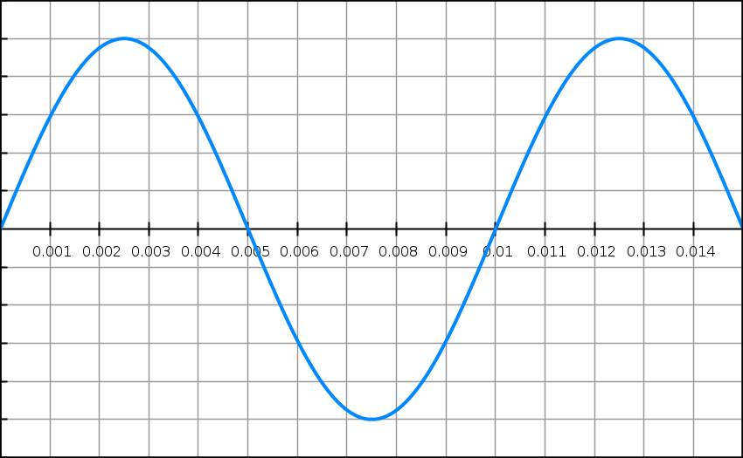

**-5**

**5**

**t (s)**

The generator consists of one coil of 20 turns, with dimensions of 10 cm x 10 cm.

Use this data, the graph and an appropriate formula to determine the strength of the magnetic field (B) in this generator. Show all working.

(5 marks)

|  |  |
| --- | --- |
| From graph, Vpeak = 5 V | 1 mark |
| From graph, T = 0.01 s; $∴f= 1/T= 1/{0.01}=100 Hz$ | 1 mark |
| A = 0.1 x 0.1 = 0.0100 m2 | 1 mark |
| Vpeak = 2πNBAf  5 = 2π x 20 x B x 0.01 x 100 | 1 mark |
| B = 3.98 x 10-2 T | 1 mark |

**Question 5**

Some students carried out an experiment to investigate the forces required to move an object up a plane. Their equipment was arranged as follows:

θ

Object

Pulley

Force probe

The object has a mass of 1.50 kg; the plane’s angle of incline (θ) is set at 25⁰. The students either held the object a rest or moved it along the plane by pulling or releasing the force probe.

When the object is at rest on the inclined plane, the static frictional force between them can be considered to be negligible. However, when the object is in motion the dynamic frictional force can be considered to be 10.0 N.

Calculate the force registered on the force probe in each of the following situations (show working):

1. The object is at rest.

(2 marks)

|  |  |
| --- | --- |
| FPROBE = mg sinθ = 1.50 x 9.80 x sin 25⁰ | 1 mark |
| $∴$ FPROBE = 6.21 N | 1 mark |

1. The object is moving at a constant velocity of 2 ms-1 up the plane’s surface.

(2 marks)

|  |  |
| --- | --- |
| FPROBE = 6.21 + 10.0 | 1 mark |
| $∴$ FPROBE = 16.2 N | 1 mark |

1. The object is accelerating at a rate of 2 ms-2 up the plane’s surface.

(2 marks)

|  |  |
| --- | --- |
| FPROBE = 6.21 + 10.0 + 1.50 x 2.00 | 1 mark |
| $∴$ FPROBE = 19.2 N | 1 mark |

**Question 6**

The diagram below shows AC voltage being supplied to a small factory. The main transmission lines supply electric power to a step down transformer at 6000 V RMS. The transformer then steps this down to 450 V RMS. The wires connecting the factory to the step down transformer have a combined resistance of 0.050 Ω. A total of 24 kW of electric power is being drawn from the output terminals of the transformer.

**Transformer**

**6000 V RMS**

**Factory**

**450 V RMS**

**Factory supply lines**

1. Calculate the power loss in the factory supply lines.

(2 marks)

|  |  |
| --- | --- |
| $$I= \frac{P}{V}= \frac{24000}{450}=53.3 A$$ | 1 mark |
| $$∴ P_{lost}= I^{2}R= {53.3}^{2} ×0.05=1.42 × {10}^{2} W$$ | 1 mark |

1. Finally, calculate the voltage delivered to the factory.

(2 marks)

|  |  |
| --- | --- |
| $$V_{delivered}= V_{T}- V_{drop}=450-53.3 ×0.05$$ | 1 mark |
| = 447 V | 1 mark |

**Question 7**

The diagram below shows a crane supporting a “heavy object” as shown. The “moving support” can be moved towards the “vertical support” or away from it.

**Cable**

**Moving support**

**Counterweight**

**Heavy object**

**Vertical support**

1. Explain the role of the “counterweight” and “cable” in this structure.

(2 marks)

|  |  |
| --- | --- |
| The weight of the ‘heavy object’ and the horizontal part of the crane to the right of the ‘vertical support’ produce clockwise moments on the crane around the ‘vertical support’. | 1 mark |
| The ‘counterweight’ and the tension in the ‘cable’ provide anticlockwise moments to balance the clockwise moments around the ‘vertical support’ and keep the crane in mechanical equilibrium. | 1 mark |

1. Explain how the tension in the cable changes if the ‘heavy object” is moved to the right by the “moving support”.

(2 marks)

|  |  |
| --- | --- |
| Moving the ‘heavy object’ increase the clockwise moments on the crane around the ‘vertical support’. | 1 mark |
| To balance this increased the clockwise moments and maintain mechanical equilibrium, the tension in the cable must increase. | 1 mark |

**Question 8**

The diagram below shows four positions on a rollercoaster track.

**A**

**D**

**B**

**C**

(a) At which point on the track do the occupants of a rollercoaster on the track experience MAXIMUM normal force? Explain.

(2 marks)

|  |  |
| --- | --- |
| At point ‘C’. | 1 mark |
| Bottom of vertical circle, N is at a maximum; $$N= F_{C}+W$$ $$∴ N= \frac{mv^{2}}{r}+mg$$ | 1 mark |

(b) The occupants of the rollercoaster feel ‘weightless’ at ‘A’. Derive an expression relating the instantaneous speed ‘v’ of the rollercoaster and the radius of the track ‘r’ at ‘A’ to cause this sensation.

(3 marks)

|  |  |
| --- | --- |
| ‘A’ is at the top of a vertical circle; if weightless (N = 0): $$\frac{mv^{2}}{r}-mg=0$$ | 1 mark |
| Hence: $$\frac{mv^{2}}{r}= mg$$ | 1 mark |
| $$∴v= \sqrt{gr}$$ | 1 mark |

**Question 9**

The diagram below shows a positive point charge near a negatively charged plate. Complete the diagram by drawing the resulting electric field created by these charged objects. Include at least 5 field lines.

(3 marks)

**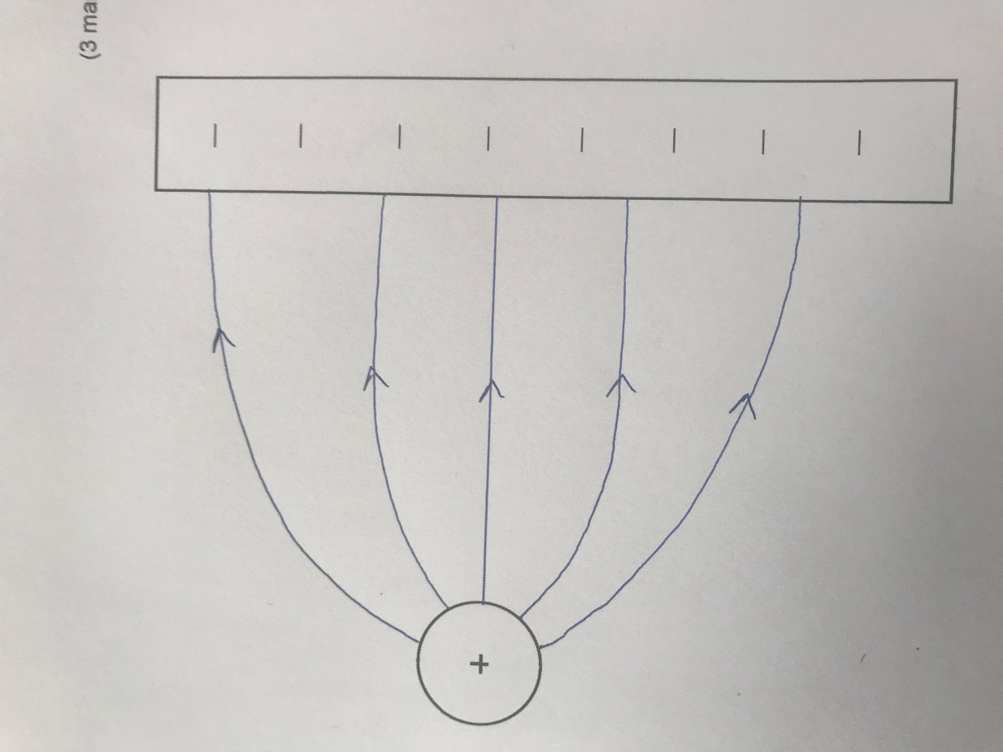**

|  |  |
| --- | --- |
| At least 5 lines drawn | 1 mark |
| Direction correct | 1 mark |
| Shape correct (lines must leave and enter point charge and plate at right angles) | 1 mark |

**Question 10**

A cyclist moves their bicycle by pushing on the pedals of their bicycle. The maximum force the cyclist can exert on one pedal is 150 N. The pedals are both 10 cm from their centre of rotation.

**35 cm**

**Pedal**

**Pedal**

**Centre of rotation**

1. Describe the location of the pedals in relation to the centre of rotation when maximum torque is being exerted by the cyclist.

(1 mark)

|  |  |
| --- | --- |
| Maximum Torque occurs when the pedals are in a horizontal position. | 1 mark |

1. Calculate the maximum torque exerted by the cyclist when the pedals are in this position.

(2 marks)

|  |  |
| --- | --- |
| TMAX = Fr sinθ = 150 x 0.10  (only the pedal being pushed downwards can produce torque) | 1 mark |
| $∴$ TMAX = 15.0 Nm | 1 mark |

1. Describe the positons of the two pedals when minimum torque is exerted by the cyclist. Explain your answer.

(2 marks)

|  |  |
| --- | --- |
| Pedals are in a vertical position. | 1 mark |
| $$∴r=0;T=0$$ | 1 mark |

**Question 11**

The diagram below shows the trajectory of a projectile as it travels from left to right (ie – from X to Y to Z.

**Y**

**Z**

**X**

|  |  |  |  |
| --- | --- | --- | --- |
|  | At ‘X’ | At ‘Y’ | At ‘Z’ |
| A |  |  |  |
| B |  |  |  |
| C |  |  |  |
| D |  |  |  |
| E |  | 0 |  |
| F |  | 0 |  |

1. Which set of vectors (A – F) best illustrates the acceleration experienced by the ball in flight (ignore air resistance)?

(1 mark)

1. Which set of vectors (A – F) best illustrates the instantaneous velocity of the ball in flight (ignore air resistance)?

(1 mark)

1. Which set of vectors best illustrates the vertical component of the ball’s velocity in flight (ignore air resistance)?

(1 mark)

1. If air resistance is taken into account, which set of vectors best illustrates the force due to this air resistance experienced by the ball in flight?

(1 mark)

|  |  |
| --- | --- |
| B | 1 mark |
| C | 1 mark |
| F | 1 mark |
| A | 1 mark |

**Question 12**

Two current carrying wires are situated 50.0 cm apart. Wire A is carrying a current of 0.500 A in an upwards direction; wire B is carrying a current of 0.375 A. The diagram below shows this situation.

Wire B

Wire A

50.0 cm

x

**P**

The point X is located between the two wires. The net magnetic field at this point due to the current in the two wires is calculated to be zero.

1. Indicate the direction of the current in Wire B.

(1 mark)

|  |  |
| --- | --- |
| Upwards | 1 mark |

1. Calculate the location of point P by calculating distance ‘x’. Show all working.

(4 marks)

|  |  |
| --- | --- |
| $$B_{A}= B_{B}$$ | 1 mark |
| $$B_{A}= \frac{μ_{o}}{2π} \frac{I}{r}= \frac{μ_{o}}{2π} \frac{0.500}{x}$$ $$B_{B}= \frac{μ_{o}}{2π} \frac{I}{r}= \frac{μ_{o}}{2π} \frac{0.375}{0.50-x}$$ | 1 mark |
| $$\frac{μ_{o}}{2π} \frac{0.500}{x}= \frac{μ_{o}}{2π} \frac{0.375}{0.50-x}$$ | 1 mark |
| $$\frac{0.500}{x}= \frac{0.375}{0.50-x}$$ $$0.375x=0.250-0.50x$$ $$0.875x=0.250$$ $$x=0.286 m$$ | 1 mark |

**End of Section One**

**Section Two: Problem-solving 50% (90 Marks)**

This section has **six (6)** questions. You must answer **all** questions. Write your answers in the space provided.

Spare pages are included at the end of this booklet. They can be used for planning your responses and/or as additional space if required to continue an answer.

● Planning: If you use the spare pages for planning, indicate this clearly at the top of the page.

● Continuing an answer: If you need to use the space to continue an answer, indicate in the original answer space where the answer is continued, i.e. give the page number. Fill in the number of the question that you are continuing to answer at the top of the page.

Suggested working time for this section is 90 minutes.

**Question 13 (16 marks)**

In 1996, a joint experiment between NASA and Italy was conducted to try and produce the world’s first space tether.

In this experiment, a spherical satellite was deployed by the Space Shuttle. The satellite and the Shuttle were connected by a 20 km long conducting tether (wire). In theory, as the Shuttle dragged the satellite and tether through the Earth’s magnetic field, electric power would be produced which could be utilised by the satellite.

The diagram below shows a view of this situation looking down towards the earth. The arrows show the direction of the orbital motion of the satellite, tether and space shuttle. The direction of the earth’s magnetic field at this point in its orbit is shown as downwards.

X X X X X X

TETHER

X X X X X X

X X X X X X

X X X X X X

X X X X X X

X X X X X X

SATELLITE

SHUTTLE

DIRECTION OF MOTION

DIRECTION OF MOTION

1. In your own words, explain the electromagnetism principle that was employed in this experiment to generate the electric power.

(2 marks)

|  |  |
| --- | --- |
| Electromagnetic induction. | 1 mark |
| As charge in the tether cuts across the Earth’s magnetic field flux lines, an EMF is induced. | 1 mark |

1. On the diagram, draw an arrow to show the direction of the conventional electric current that was generated by the motion of the tether.

(1 mark)

|  |  |
| --- | --- |
| Current is to the right. | 1 mark |

1. One of the design faults that had to be overcome with the above setup was that the electric power generated slowed the shuttle and satellite down.
2. Explain why the orbital speed of the Shuttle, tether and satellite would have reduced due to the electric power generated.

(2 marks)

|  |  |
| --- | --- |
| Lenz’s law states that the induced EMF/current in the tether must oppose the change that produced it. | 1 mark |
| Hence, a magnetic force is created that opposes the motion of the tether, Shuttle and satellite. | 1 mark |

1. The electric power generated was stored in batteries on the satellite. The stored charge from this battery was used to combat the problem described in part (i); it could even be used to increase the orbital speed of the Shuttle, tether and satellite. Explain how this could occur using electromagnetism concepts. As part of your answer, show on the diagram the direction current would have to flow from the batteries to achieve this.

(3 marks)

X X X X X X

X X X X X X

X X X X X X

X X X X X X

X X X X X X

X X X X X X

|  |  |
| --- | --- |
| Current is to the left. | 1 mark |
| If the tether carries a current to the left, a magnetic force in the same direction as the motion of the tether, Shuttle and satellite is created. | 1 mark |
| A force in this direction will result in an increasing velocity for the tether, Shuttle and satellite. | 1 mark |

The Shuttle, tether and satellite followed an orbit around the earth with an average altitude 296 km.

1. Using data from your Formulae and Constants Sheet, calculate the orbital speed of the Shuttle, tether and satellite around the earth.

(3 marks)

|  |  |
| --- | --- |
| $$m_{EARTH}=5.97 × {10}^{24} kg;r=6.38 × {10}^{6}+296 × {10}^{3}=6.68 × {10}^{6} m$$ | 1 mark |
| $$F_{c}= F_{G}; {m_{S}v^{2}}/r= {Gm_{E}m_{S}}/{r^{2}}; ∴v= \sqrt{{Gm_{E}}/r}$$ $$v= \sqrt{{6.67 x {10}^{-11} ×5.97 × {10}^{24}}/{6.68 × {10}^{6}}}$$ | 1 mark |
| $$v=7.72 × {10}^{3} ms^{-1}$$ | 1 mark |

The maximum EMF generated by the tether was about 3500 V.

1. As the tether was unfurled to its full length, scientists predicted that the EMF generated would increase in a highly predictable way. Explain.

(2 marks)

|  |  |
| --- | --- |
| Since EMF is directly proportional to ‘l’, | 1 mark |
| As ‘l’ increases, so will EMF generated (‘B’ and ‘v’ remain constant). | 1 mark |

1. Use the maximum EMF generated and previous data in this question to calculate the strength of the earth’s magnetic field at this altitude. [If you were unable to calculate the orbital speed in part (d), use a value of 7.50 x 103 ms-1]

(3 marks)

|  |  |
| --- | --- |
| $${EMF}_{max}=lvB$$ | 1 mark |
| $$3500=20000 x 7.72 × {10}^{3} ×B$$ | 1 mark |
| $$∴B=2.27 × {10}^{-5} T$$ | 1 mark |
| $$If v=7.50 × {10}^{3} ms^{-1} is used, then B= 2.33 × {10}^{-5} T)$$ |  |

**Question 14 (16 marks)**

An archer is challenged to hit an apple with an arrow.

The apple is thrown vertically upwards into the air with a velocity of 10ms-1. At the same instant, the archer – who is located a horizontal distance of 17.2m from where the apple is launched – fires the arrow at an angle (θ) and speed (v). The apple and arrow are both launched from the same height.

The archer manages to hit the apple 4.00m above its launch height on its downward path.

1. Show through calculations that the maximum height attained by the apple is 5.10m.

(3 marks)

|  |  |
| --- | --- |
| $$v^{2}= u^{2} +2as, ∴s= \frac{\left(v^{2}- u^{2}\right)}{2as}$$ | 1 mark |
| $$∴s= \frac{\left(0- {10}^{2}\right)}{2 × -9.8}$$ | 1 mark |
| $$s=5.10m$$ | 1 mark |

1. In the space below, draw a diagram showing the paths taken by the arrow and the apple from launch until impact. Also include any relevant distances to indicate scale.

(3 marks)

5.10m

4.00m

17.2m

|  |  |
| --- | --- |
| Parabolic path for arrow; up and down path for apple. | 1 mark |
| Horizontal distances (17.2m) shown. | 1 mark |
| Vertical distances (4.00m and 5.10m) shown. | 1 mark |

1. Calculate the time taken for the arrow to hit the apple.

(4 marks)

|  |  |
| --- | --- |
| $$s=ut + 1/2at^{2}; ∴4.00=10t-4.9t^{2}$$ | 1 mark |
| $$4.9t^{2}-10t +4=0$$ | 1 mark |
| $$t= \frac{10 ± \sqrt{100-4×4.9×4}}{9.8}$$ | 1 mark |
| $$t=1.49s$$ | 1 mark |

1. Hence, calculate the horizontal component of the arrow’s launch velocity. [If you were unable to calculate an answer for part (c), use a time of 1.30s]

(2 marks)

|  |  |
| --- | --- |
| $$v= \frac{s}{t}= \frac{17.2}{1.49}$$ | 1 mark |
| $$∴ v_{h}=11.5 ms^{-1}$$ | 1 mark |

1. Finally, using the information you have calculated earlier in this question, determine the initial launch velocity of the arrow. Show all working. Include a vector diagram in your answer. [If you were unable to calculate an answer for part (d), use a horizontal velocity of 11.0ms-1]

(4 marks)

θ

11.0 ms-1

10.0 ms-1

v

|  |  |
| --- | --- |
| Vector diagram correct, all quantities labelled. | 1 mark |
| Magnitude calculated to 15.2ms-1. | 1 mark |
| Angle ‘θ’ calculated to 41.0⁰ $$\tan{θ= \frac{10}{11.5}, ∴ θ=41.0°}$$ | 1 mark |
| Answer given as a final statement giving reference to the horizontal (or vertical). | 1 mark |

**Question 15 (15 marks)**

The graph below shows how the torque on one (1) coil in an experimental DC motor varies over time.

**Torque (Nm)**

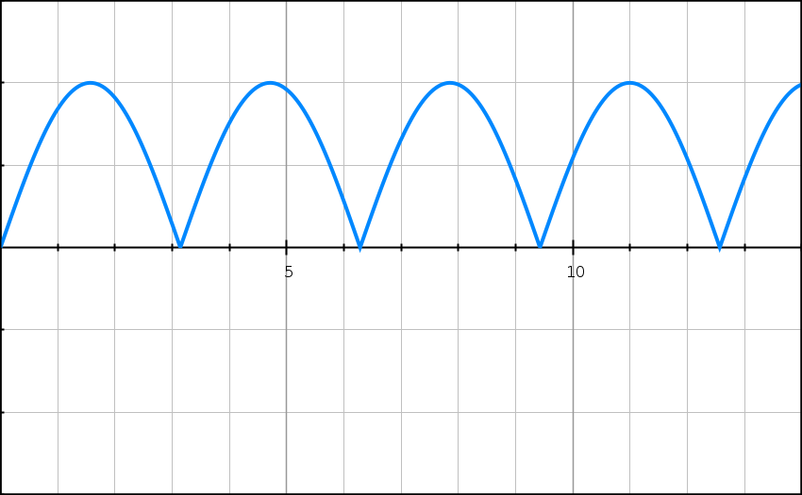

**Time (ms)**

**-0.10**

**-0.05**

**0.10**

**0.05**

1. On the graph, mark one (1) point where:
2. the coil would be parallel to the magnetic field. Label this point ‘X’.

(1 mark)

|  |  |
| --- | --- |
| ‘X’ should be located at points of MAXIMUM torque. | 1 mark |

1. the coil would be perpendicular to the magnetic field. Label this point ‘Y’.

(1 mark)

|  |  |
| --- | --- |
| See graph for an example – ‘Y’ should be locate at points of ZERO torque. | 1 mark |

1. Briefly explain your answer to part (i). A simple diagram should be included in your explanation.

(2 marks)

|  |  |
| --- | --- |
| When the coil is parallel to the magnetic field, the angle between the applied magnetic force and the lever arm ‘r’ (θ) is 90⁰. | 1 mark |
| Given that T = Fr sinθ, the torque experienced by the coil in this position will be at a maximum (sin 90⁰ = 1.00). | 1 mark |

1. The shape of this graph suggests the presence of a commutator. Explain.

(2 marks)

|  |  |
| --- | --- |
| The commutator is designed to reverse the direction of the current in the coil every half-turn. | 1 mark |
| This ensures that the direction of the torque experienced by the coil is in one direction only and is illustrated by the graph only having a positive torque. | 1 mark |

Some specifications for the coil and the DC motor are shown below:

Current in coil (I) = 0.500 A

Dimensions of coil (square shape): 20 cm x 20 cm

Number of turns (n) = 20

1. Using appropriate formulae from your Formulae and Constants Sheet, show that the maximum torque (TMAX) generated by the coil can be derived by the following expression:

$$τ_{max}=IBAn$$

Where ‘B’ is equal to the magnetic field strength in the DC motor.

(3 marks)

|  |  |
| --- | --- |
| $$τ_{MAX}=2 ×Fr=2 x IBln x r$$ | 1 mark |
| $$=2 × IBn ×l × w/2$$ | 1 mark |
| $$=IBn ×lw=IBnA$$ | 1 mark |

1. Using the expression in part (c), the graph at the beginning of this question, and the specifications of the DC motor, calculate the magnetic field strength B in the DC motor.

(3 marks)

|  |  |
| --- | --- |
| $$τ_{MAX}=0.10 Nm (from graph)$$ | 1 mark |
| $$0.10=0.500 ×B ×0.20 ×0.20 ×20$$ | 1 mark |
| $$∴B=0.250 T$$ | 1 mark |

1. If the DC motor ‘jams’ and stops rotating, it has designed safeguards to prevent it from overheating and ‘burning out’. Without describing these safeguards, explain why they are necessary in this particular situation.

(3 marks)

|  |  |
| --- | --- |
| The normal movement of a rotating coil induces a back emf, or emf with opposite polarity to the supply. | 1 mark |
| In the absence of the back emf, a stationary coil will experience a much higher net emf. | 1 mark |
| Hence, the current in the coil will increase beyond the specifications of the circuit. | 1 mark |

**Question 16 (16 marks)**

A 60.0 kg person is standing on the end of a uniform 5.00 m long viewing platform with a mass of 500 kg. The platform is horizontal and extends out from the side of a cliff face. It is supported by a steel beam that extends from the side of the cliff face to the end of the platform. The platform is shown below. ‘P’ is the point of contact between the viewing platform and the cliff face.

Cliff face

Viewing Platform

60⁰

P

Steel Beam

1. In the space below, draw a free body diagram showing all of the forces acting on the viewing platform with the 60.0 kg person standing in the position stated at the beginning of the question. Label the forces appropriately.

(3 marks)

|  |  |
| --- | --- |
| F (beam)  F (P)  W (platform)  W (person) | W (platform) and W (person) = 1 mark  F (P) = 1 mark  F (beam) = 1 mark |

1. Show, with a calculation, that the size of the force exerted by the steel beam is approximately 6.1 x 103 N.

(5 marks)

|  |  |
| --- | --- |
| Take moments about ‘P’, ΣMC = ΣMA |  |
| W (person) = 60 x 9.8 = 588 N  W (platform) = 500 x 9.8 = 4900 N | 1 mark |
| 4900 x 2.5 + 588 x 5 = F x 5 x sin 30⁰ | 2 marks |
| F = 15190/2.50 | 1 mark |
| F = 6.08 x 103 N | 1 mark |

1. Hence, calculate the magnitude of the force exerted by ‘P’ (ie – the cliff face) on the viewing platform. You may need to alter your answer to part (a) as a result of this calculation.

(5 marks)

|  |  |
| --- | --- |
| 6.08 x 103 x cos 30⁰  = 5.27 x 103 N  6.08 x 103 x sin 30⁰  = 3.04 x 103 N  30⁰  6.08 x 103 N | 2 marks |
|  | 1 mark |
|  | 1 mark |
| 5.27 x 103 N  2.45 x 103 N N  FP | 1 mark |

1. The person now walks towards the cliff face. In your own words, describe how the force exerted by the beam would change as this occurred. Explain your answer.

(3 marks)

|  |  |
| --- | --- |
| As the person moves towards the cliff face, the size of their moment will decrease (because ‘r’ decreases). | 1 mark |
| Hence, size of the moment provided by the beam will decrease to maintain equilibrium. | 1 mark |
| Therefore, the size of the force exerted by the beam will decrease. | 1 mark |

**Question 17 (17 marks)**

The diagram below shows the primary coil and secondary coil in a stepdown transformer. They are both wrapped around a ring made of iron.

**Secondary coil**

**12 V AC RMS 50 Hz**

**??? W**

**??? turns**

**Primary coil**

**240 V AC RMS 50 Hz**

**10 000 W**

**1000 turns**

**Iron core**

1. Use the data above to determine the number of turns in the secondary coil. Show all working.

(2 marks)

|  |  |
| --- | --- |
| $$\frac{V_{P}}{V_{S}}= \frac{N_{P}}{N_{S}}; \frac{240}{12}= \frac{1000}{N_{S}}$$ | 1 mark |
| $$∴ N_{S}=50.0 turns$$ | 1 mark |

1. Now assume the transformer is NOT ‘ideal’ and its ‘efficiency’ is measured to be 90%. Given this, calculate the power generated in the transformer’s secondary coil.

(2 marks)

|  |  |
| --- | --- |
| $$P_{S}=0.90 × P_{P}=0.90 ×10000$$ | 1 mark |
| $$∴ P_{S}=9000 W$$ | 1 mark |

1. The power losses that reduce the efficiency of the transformer originate in the COILS and the IRON CORE RING. These losses can be reduced through careful design of the transformer. For each of the COILS and IRON CORE RING, describe one (1) modification that is made and how it reduces the power losses. Refer specifically to the transformer at the start of this question.

(4 marks)

1. COILS

|  |  |
| --- | --- |
| In this transformer, the secondary coil carries the higher current. | 1 mark |
| The secondary coil would be made of thicker wire to reduce resistance and therefore heat losses. | 1 mark |

1. IRON CORE RING

|  |  |
| --- | --- |
| The iron core will have eddy currents induced in them due to the changing magnetic field. | 1 mark |
| To reduce the size of these eddy currents the iron core is laminated. | 1 mark |

1. The graph below shows how the emf varies over time in the primary coil. On the same set of axes, draw the corresponding graph of emf v time graph for the secondary coil. When drawing this graph, consider the following:

* What is the shape of this graph?
* What is VPEAK for the secondary coil? (You may wish to show a calculation in the space below)
* What is the period (T) for this EMF v time graph?
* When would VPEAK occur in the secondary coil?

(3 marks)

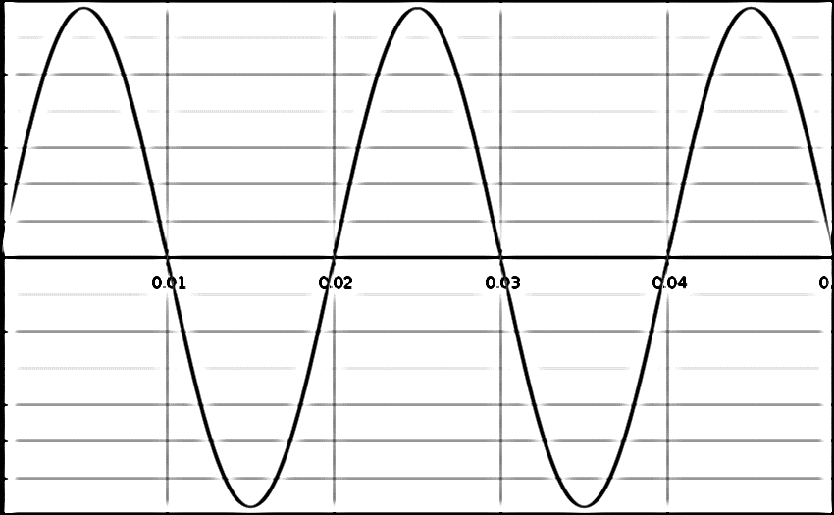

**time (s)**

**EMF (V)**

**-300**

**-200**

**-100**

**300**

**200**

**100**

**EMF in Secondary Coil (V)**

**time (s)**

**17.0**

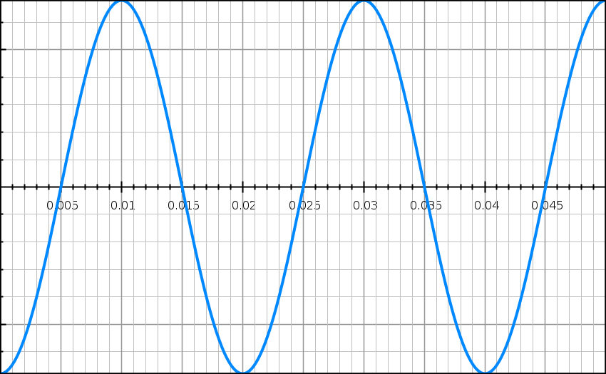

**-17.0**

|  |  |
| --- | --- |
| $$Secondary Coil; V_{peak}= \sqrt{2} x 12.0=17.0 V$$ | 1 mark |
| Shape of graph | 1 mark |
| Period of graph, T = 0.02 s | 1 mark |

1. Step-up transformers are generally found at the start of our transmission system (eg – at the power station itself where electric power is generated). Explain why it is necessary to ‘step up’ transmission voltage early in the transmission process.
2. (3 marks)

|  |  |
| --- | --- |
| There are power losses due to heat in the power lines (PLOST = I2R). | 1 mark |
| Power is transmitted at a constant rate: PT = VTIT. | 1 mark |
| Hence, if transmission voltage (VT) is increased, transmission current (IT) is decreased and power loss is reduced. | 1 mark |

(f) If the EMF in the primary coil were to remain constant as shown in the graph, describe in words the effect this would have on the EMF in the secondary coil. Explain your answer.

(3 marks)

|  |  |
| --- | --- |
| The EMF in the primary coil (and, hence the current) is constant. | 1 mark |
| Hence, the magnetic field due to the primary coil passing through the secondary coil is also constant. | 1 mark |
| Therefore, the change in flux through the secondary coil is zero; induced EMF = 0. | 1 mark |

**Question 18 (10 marks)**

A small object of mass 50.0 g is being rotated freely in a vertical circle of radius 1.50 m. It is attached to a string of the same length. At the position shown (ie – the top of the vertical circle), the tension in the string is momentarily equal to zero. The string is able to withstand a maximum tension of 2.50 N before it snaps.

object

Direction of motion

v = 1.00 ms-1

r = 1.50 m

X

Y

1. Which of the arrows below best describes the direction of the object’s motion at point ‘X’?

(1 mark)

|  |  |
| --- | --- |
| A |  |
| B |  |
| C |  |
| D |  |

|  |  |
| --- | --- |
| C | 1 mark |

1. Show via calculation that the object is travelling with a speed 3.83 ms-1 when it is at the top of the vertical circle.

(3 marks)

|  |  |
| --- | --- |
| $$At top, N= \frac{mv^{2}}{r}-mg; N=0; ∴v= \sqrt{gr}$$ | 1 mark |
| $$∴v= \sqrt{9.80 ×1.50}$$ | 1 mark |
| $$v=3.83 ms^{-1}$$ |  |

1. Given that the object is rotating freely under the influence of gravity, calculate what its speed would be if it reached the bottom of the circle at point ‘Y’.

(3 marks)

|  |  |
| --- | --- |
| $$E_{TOTAL}=0.5×0.050×{3.83}^{2}+0.050×9.80×3=1.84 J$$ | 1 mark |
| $$At{{}_{}^{'}Y}^{'}, 1.84=0.5×0.050×v^{2}$$ $$∴v= \sqrt{\frac{2 x 1.84}{0.050}}$$ | 1 mark |
| $$∴v=8.57 ms^{-1}$$ | 1 mark |

1. Hence determine whether the string would snap before the object reaches Y’. Support your answer with a calculation.

[If you were unable to calculate an answer for part (c), use a value of 8.60 ms-1]

(3 marks)

|  |  |
| --- | --- |
| $$At{{}_{}^{'}Y}^{'}, N= F_{C}+W= \frac{mv^{2}}{r}+mg$$ | 1 mark |
| $$∴N= \frac{0.050 × {8.57}^{2}}{1.50}+0.050 ×9.80=2.94 N$$ | 1 mark |
| 2.94 N > 2.50 N. Hence, the string will snap. | 1 mark |

**End of Section 2**

**Section Three: Comprehension and Data Analysis 20% (36 Marks)**

This section contains **two (2)** questions. You must answer both questions. Write your answers in the space provided.

Spare pages are included at the end of this booklet. They can be used for planning your responses and/or as additional space if required to continue an answer.

● Planning: If you use the spare pages for planning, indicate this clearly at the top of the page.

● Continuing an answer: If you need to use the space to continue an answer, indicate in the original answer space where the answer is continued, i.e. give the page number. Fill in the number of the question that you are continuing to answer at the top of the page.

Suggested working time for this section is 40 minutes.

**Question 19 (18 marks)**

A group of students conducted an investigation to calculate an experimental value for **‘μ0’ – the magnetic constant**. They had the following equation from their Formulae and Constants Sheet at their disposal:

$$B= \frac{μ_{0}}{2π} \frac{I}{r}$$

Where μ0 = the magnetic constant; I = current in the conductor; r = distance from the conductor.

They also had the following equipment at their disposal:

1 x power pack; 1 x ammeter; 1 x 50cm length of straight conductor; 1 x rheostat; 1 x switch; 2 x wooden stands; 4 x wooden blocks; 1 x orienteering compass; 1 x ruler; enough connecting wires and alligator clips as required.

The horizontal straight conductor is connected into a circuit that allows the current flowing through it to be controlled. **This current is set at a constant value of 5.00 A.**

The horizontal straight conductor is aligned in a North-South direction using the compass. It is elevated 40 cm above the bench by the wooden stands.

The compass is set on wooden blocks directly beneath the straight conductor. The distance the compass is below the straight conductor ‘r’ can be varied.

**The earth’s magnetic field strength (BE) is known to be equal to 5.00 x 10-5 T** and can be considered to be horizontal in this part of the laboratory.

The diagrams below offer some more information about this set up.

**SIDE VIEW**

**Straight conducting wire**

**r**

**Compass**

**Wooden stand**

**Wooden stand**

**Wooden blocks**

**TOP VIEW**

**Compass**

**Straight conductor aligned in a North-South direction**

NORTH

When the current in the straight conductor is turned on, the compass needle deviates through an angle ‘θ’. This deviation is due to the magnetic field produced by the current-carrying conductor (BI). With this orientation of the straight conductor, ‘BE’ and ‘BI’ are both perpendicular to each other. Their relationship with ‘θ’ is shown below:

**BI**

**θ**

**BE**

Using the above concept, the students were able to calculate experimental values for ‘BI’ at different distances ‘r’ from the wire. They collected two values for ‘θ’ at each distance ‘r’ by reversing the current for each trial. The values they collected are displayed in the table below:

|  |  |  |  |  |  |  |
| --- | --- | --- | --- | --- | --- | --- |
| r (m) | θleft | θright | θaverage | tan θ | BI (x 10-5 T) | 1/r (m-1) |
| 0.050 | 21.5⁰ | 22.1⁰ | 21.8⁰ | 0.400 |  | 2.0 x 101 |
| 0.10 | 10.7⁰ | 11.9⁰ | 11.3⁰ | 0.200 | 1.00 | 1.0 x 101 |
| 0.15 | 6.5⁰ | 8.7⁰ | 7.6⁰ | 0.134 | 0.67 |  |
| 0.20 |  | 6.2⁰ | 5.7⁰ | 0.100 | 0.50 | 5.0 |
| 0.25 | 4.3⁰ | 4.7⁰ | 4.5⁰ | 0.080 | 0.40 | 4.0 |
| 0.30 | 3.4⁰ | 4.0⁰ | 3.7⁰ | 0.066 | 0.33 | 3.3 |

1. On the diagram below, draw an arrow on the straight conductor to show the direction of conventional current that would have produced the deflection shown on the compass.

(1 mark)

**TOP VIEW**

**Compass**

**Straight conductor aligned in a North-South direction**

NORTH

|  |  |
| --- | --- |
| Conventional current – downwards arrow on conductor. | 1 mark |

1. Explain why the students collected two different values of ‘θ’ (θleft and θright). As part of your answer, also explain why wooden stands are used to elevate the straight conductor instead of steel retort stands.

(3 marks)

|  |  |
| --- | --- |
| The direction of the Earth’s magnetic field can be distorted locally by the presence of ferromagnetic materials. | 1 mark |
| Wooden stands are not made of ferromagnetic materials. | 1 mark |
| Deflections left and right are collected to try and control the variable of this distortion of the earth’s magnetic field by ferromagnetic materials. | 1 mark |

1. The table is incomplete. Calculate values for these missing quantities and write them in the table. Show your working in the space below. Round to the correct number of significant figures.

(3 marks)

|  |  |
| --- | --- |
| $$r=0.05 m; B_{I}=5 × {10}^{-5} × \tan{21.8°}=2.00 × {10}^{-5}T$$ | 1 mark |
| $$r=0.15 m; \frac{1}{r}= \frac{1}{0.15}=6.67 m^{-1}$$ | 1 mark |
| $$r=0.20 m; θ_{average}= \frac{θ_{left} + θ_{right}}{2}; ∴5.7= \frac{θ_{left}+6.2}{2} ; ∴ θ_{left}=5.2°$$ | 1 mark |

1. On the grid on the next page, plot a graph of ‘BI’ against ‘1/r’ (place ‘BI’ values on the vertical axis). Draw a line of best fit for your data.

(4 marks)

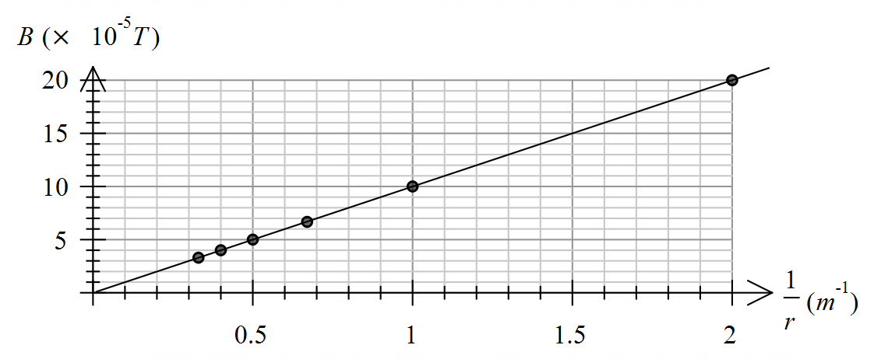

2.0

1.5

1.0

0.5

5

10

15

20

|  |  |
| --- | --- |
| BI on the vertical (y) axis. | 1 mark |
| Correct units supplied. | 1 mark |
| Points correctly plotted. | 1 mark |
| Line of best fit correctly drawn. | 1 mark |

1. Calculate the gradient of the line of best fit. Show working below. Include units.

(4 marks)

|  |  |
| --- | --- |
| Uses points of the line of best fit; eg – $\left(2.00 × {10}^{-5}, 19.9\right) and \left(0.3 × {10}^{5}, 3\right)$ | 1 mark |
| $$Slope= \frac{2.00 × {10}^{-5}-0.3 × {10}^{-5}}{19.9-3}$$ | 1 mark |
| $=1.01 × {10}^{-6}$ (accept between 0.80 x 10-6 and 1.20 x 10-6) | 1 mark |
| Tm (units) | 1 mark |

1. Use your answer from part (e) to calculate an experimental value for the magnetic constant ‘μ0’. Show your working.

(3 marks)

|  |  |
| --- | --- |
| $$B= \frac{μ_{0}}{2π} \frac{I}{r}; slope= B/{1/r}=Br$$ | 1 mark |
| $$∴slope= \frac{μ_{0}}{2π} . I; μ_{0}= \frac{slope ×2π}{I}$$ | 1 mark |
| $∴ μ_{0}= \frac{1.01 × {10}^{-6 } ×2π}{5}=1.26 × {10}^{-6}$ (accept between 1.01 x 10-6 and 1.51 x 10-6) | 1 mark |

|  |  |  |  |  |  |  |  |  |  |  |  |  |  |  |  |  |
| --- | --- | --- | --- | --- | --- | --- | --- | --- | --- | --- | --- | --- | --- | --- | --- | --- |
|  |  |  |  |  |  |  |  |  |  |  |  |  |  |  |  |  |
|  |  |  |  |  |  |  |  |  |  |  |  |  |  |  |  |  |
|  |  |  |  |  |  |  |  |  |  |  |  |  |  |  |  |  |
|  |  |  |  |  |  |  |  |  |  |  |  |  |  |  |  |  |
|  |  |  |  |  |  |  |  |  |  |  |  |  |  |  |  |  |
|  |  |  |  |  |  |  |  |  |  |  |  |  |  |  |  |  |
|  |  |  |  |  |  |  |  |  |  |  |  |  |  |  |  |  |
|  |  |  |  |  |  |  |  |  |  |  |  |  |  |  |  |  |
|  |  |  |  |  |  |  |  |  |  |  |  |  |  |  |  |  |
|  |  |  |  |  |  |  |  |  |  |  |  |  |  |  |  |  |
|  |  |  |  |  |  |  |  |  |  |  |  |  |  |  |  |  |
|  |  |  |  |  |  |  |  |  |  |  |  |  |  |  |  |  |
|  |  |  |  |  |  |  |  |  |  |  |  |  |  |  |  |  |
|  |  |  |  |  |  |  |  |  |  |  |  |  |  |  |  |  |
|  |  |  |  |  |  |  |  |  |  |  |  |  |  |  |  |  |
|  |  |  |  |  |  |  |  |  |  |  |  |  |  |  |  |  |
|  |  |  |  |  |  |  |  |  |  |  |  |  |  |  |  |  |
|  |  |  |  |  |  |  |  |  |  |  |  |  |  |  |  |  |
|  |  |  |  |  |  |  |  |  |  |  |  |  |  |  |  |  |
|  |  |  |  |  |  |  |  |  |  |  |  |  |  |  |  |  |
|  |  |  |  |  |  |  |  |  |  |  |  |  |  |  |  |  |
|  |  |  |  |  |  |  |  |  |  |  |  |  |  |  |  |  |
|  |  |  |  |  |  |  |  |  |  |  |  |  |  |  |  |  |
|  |  |  |  |  |  |  |  |  |  |  |  |  |  |  |  |  |

**Question 20 (18 marks)**

“Cassini Mission to Saturn”

From 10 Cassini fact sheet

(Source: <https://saturn.jpl.nasa.gov/system/downloadable_items/10_cassini_fact_sheet.pdf>)

The Cassini mission to Saturn is the most ambitious effort in planetary space exploration ever mounted.

Launched in 1997, Cassini will reach Saturn in 2004 after an interplanetary cruise spanning nearly seven years. Along the way, it has flown past Venus, Earth and Jupiter in “gravity assist” manoeuvres to increase the speed of the spacecraft.

**The Mission**

In manoeuvres called gravity-assist swing-by’s, Cassini flew twice past Venus, then once each past Earth and Jupiter. The spacecraft’s speed relative to the Sun increased as it approached and swung around each planet, giving Cassini the cumulative boost it needs to reach Saturn.

Cassini executed its first Venus flyby on April 26, 1998, at an altitude of 287.2 kilometres. The second Venus flyby took it within 600 kilometres of the planet on June 24, 1999. Two months later, on August 18, 1999, Cassini swung past Earth at an altitude of 1,171 kilometres. It flew by Jupiter at an altitude of 9.7 million kilometres on December 30, 2000.

Upon reaching Saturn on July 1, 2004, Cassini will fire its main engine for about 96 minutes to brake the spacecraft’s speed and allow it to be captured as a satellite of Saturn. Passing through a gap between two of Saturn’s rings, called F and G rings, Cassini will swing in close to the planet – to an altitude only one-sixth the diameter of Saturn itself – to begin the first of 75 orbits during the rest of its four-year mission.

Saturn is colder than Jupiter, but the colours of Saturn’s cloud layers are due to the same basic cloud chemistry as on Jupiter. Near the top of the atmosphere, the ammonia becomes cold enough to crystallize into ice particle clouds, much like high cirrus clouds in Earth’s skies. These ammonia clouds are the visible part of Saturn. Gravity at the top of Saturn’s clouds is similar to the gravity near the surface of Earth.

Saturn is 9½ times farther from the Sun than Earth is, so it receives only about 1 percent as much sunlight per square metre as does Earth.

**The Rings**

Although the best telescopes on Earth show three nested main rings about Saturn, we now know that the ring system is collection of thousands of ringlets. They are not solid but rather are made up of countless unconnected particles, ranging in size from nearly invisible dust to icebergs the size of a house. The spacing and width of the ringlets are orchestrated by gravitational tugs from a retinue of orbiting moons and moonlets, some near ring edges but most far beyond the outermost main rings.

And what is the origin of the rings themselves? One theory is that they are the shattered debris of moons broken apart by repeated meteorite impacts. Scientists believe that Saturn’s ring system may even serve as a partial model for the disk of gas and dust from which all the planets formed about the early Sun. The Cassini mission will undoubtedly provide important clues to help determine the answers.

**The Cassini Spacecraft**

The Cassini spacecraft, including the orbiter and the Huygens probe, is one of the largest, heaviest and most complex interplanetary spacecraft ever built. The orbiter alone weighs 2,125 kilograms. When the 320-kilogram Huygens probe and a launch vehicle adapter were attached and 3,132 kilograms of propellants were loaded, the spacecraft at launch weighed 5,712 kilograms. Of all interplanetary spacecraft, only the two Phobos spacecraft sent to Mars by the former Soviet Union were heavier.

1. Describe how Cassini was able to increase its speed relative to the Sun by using “gravity-assist swing-by’s” around planets like Venus and the Earth. Use a diagram as part of your answer.

(3 marks)

|  |  |
| --- | --- |
| Cassini used the motion of the planet to ‘pull’ on it in the direction of its motion to increase its speed. | 1 mark |
| Diagram – planet and its direction of motion indicated. | 1 mark |
| Diagram – motion of spacecraft indicated. | 1 mark |

Path of planet

Path of Cassini

1. The rings of Saturn consist of “countless unconnected particles, ranging in size from nearly invisible dust to icebergs the size of a house.” In a particularly thin ring, the orbital speed of each these vastly different masses would be the same. Using relevant formulae, explain.

(3 marks)

|  |  |
| --- | --- |
| ‘Objects’ in the ‘same ring’ have the same orbital radius ‘r’. | 1 mark |
| $$v= \sqrt{{Gm}/r or mentions Kepler^{'}s3rd Law;period \left(T\right)is independent of mass.}$$ | 1 mark |
| Hence, the orbital speed ‘v’ of a satellite depends on the orbital radius ‘r’; and the mass of the central body ‘m’ (in this case, mass of Saturn). ‘v’ is independent of the mass of the satellite. | 1 mark |

1. Cassini’s orbit around Saturn is at an altitude of only one-sixth the diameter of Saturn itself. Saturn’s diameter is 116 464km; and its mass is 5.68 x 1026 kg.
2. Calculate the radius of Cassini’s orbit around Saturn (in metres).

(2 marks)

|  |  |
| --- | --- |
| $$r= \frac{116464 × {10}^{3}}{2}+ \frac{116464 × {10}^{3}}{6}$$ | 1 mark |
| $$∴r=7.76 × {10}^{7} m$$ | 1 mark |

1. Hence, calculate the orbital speed of Cassini at this altitude. Show working.

(3 marks)

|  |  |
| --- | --- |
| $$F_{c}= F_{g}; \frac{m_{C}v^{2}}{r}= \frac{GM_{S}m_{C}}{r^{2}}; ∴v= \sqrt{\frac{GM_{S}}{r}}$$ | 1 mark |
| $$v= \sqrt{\frac{6.67 × {10}^{-11} ×5.68 × {10}^{26}}{7.76 × {10}^{7}}}$$ | 1 mark |
| $$=2.21 × {10}^{4} ms^{-1}$$ | 1 mark |

1. A quote from paragraph 6 states that: “Gravity at the top of Saturn’s clouds is similar to the gravity near the surface of Earth.”
2. The data in part (c) illustrates how much bigger in volume Saturn is compared to the earth. Hence, explain how gravity at the top of Saturn’s clouds could be similar to the gravity near the surface of Earth.

(3 marks)

|  |  |
| --- | --- |
| Gravitational field strength: $g= {Gm}/{r^{2}}$ | 1 mark |
| r (Saturn) > r (Earth). | 1 mark |
| density (Saturn) < density (Earth). | 1 mark |

(ii) Hence, using data provided in part (c), calculate an estimate for the height of the clouds above Saturn’s surface.

(4 marks)

|  |  |
| --- | --- |
| $$g_{E} \left(surface\right)=9.80 ms^{-2}; ∴ g_{S}=9.80 ms^{-2}$$ | 1 mark |
| $$9.80= \frac{GM_{S}}{r^{2}}; ∴r= \sqrt{\frac{GM_{S}}{9.8}}$$ | 1 mark |
| $$r= \sqrt{\frac{6.67 × {10}^{-11} ×5.68 × {10}^{26}}{9.80}} =6.22 × {10}^{7} m$$ | 1 mark |
| $$∴h=6.22 × {10}^{7}- \frac{116464 × {10}^{3}}{2}=3.94 × {10}^{6} m$$ | 1 mark |

**End of Section 3**

**Additional working space**

**Additional working space**

**Additional working space**

**Additional working space**

**Additional graph if required.**

Macintosh HD:Users:wijaya.joni:Desktop:Metric_20mm&2mm_Linear_LightGray&Watermark_MC-Port_Letter.pdf

**End of examination**